CTA Mod 8 Option 1: Capstone Project: U.S. Organization – Final Project
Patrick Hauer
MIS581 Capstone Class
Colorado State University – Global Campus
Dr. Steven Chung
March 8, 2020
Organization - Accumen Inc.
The U.S. organization chosen for this Capstone Project is Accumen, Inc. This company was chosen in part because the author began working here as a Project Analyst in December 2019. Accumen is a consulting company in the healthcare industry. Accumen works with hospitals and health systems, and Accumen is owned by a private equity group called Arsenal Capital Partners. Accumen was founded in 2011. Since Acumen’s founding, it has acquired several other companies including Chi Solutions, Halfpenny Technologies, 3DR Laboratories, and Anemia Management. Accumen is headquartered in Phoenix, Arizona, but also has an office in San Diego, California. In addition, Accumen has employees that work remotely across the country (Accumen, 2020).
As this is a private company, it is difficult to find published and/or reliable numbers on the number of employees and revenue of the company. The estimated number of employees is 350. The author works specifically within a group of about 10 individuals who focus on consulting with medical laboratories. This group advises on lab and space design, outreach and consolidation of testing, as well as other aspects to increases efficiencies within the lab and lower the cost per test. Accumen’s offerings can best be described on their website and include:
“strategic solutions, services and technology that deliver sustainable performance improvements in operations, clinical services, and data management. These offerings include lab and imaging transformation, consulting, supply chain optimization, lab outreach, patient blood utilization, test utilization, anemia management and clinical data exchange” (Accumen, 2020).
This company was chosen because the author works there, and this analysis can provide a concrete contribution and direction for business development. Suhail Doshi of Mixpanel expands on this thought: “Most of the world will make decisions by either guessing or using their gut. They will be either lucky or wrong.” (Sanders, 2020). Companies need a data-driven approach to making decisions about what customers to pursue. These choices about how to allocate resources to ensure growth cannot be left to chance. The tools and methodologies exist, and the opportunity is too great to be gambled away by a lack of effort, discipline, and due diligence. This consulting group needs to identify prospective health systems and hospitals to reach out to for consulting engagements. It is vital that time and other resources (like marketing budgets) are not wasted in reaching out to potential customers that would not be a good fit for Accumen to enter into a consulting relationship with. The balance between benefits and costs must be considered (Grover, et al., 2018). Accumen needs a more targeted approach for marketing and advertising. Through the analysis in this project, Accumen can begin to create a customer profile for the types of institution they need to reach out to.
Explanation of Dataset
The dataset being using for this project largely comes from Definitive Healthcare (DHC). Definitive Healthcare is a database online that requires paid access (by monthly subscription). DHC is a “provider of data and intelligence on hospitals, physicians and other healthcare providers” (DHC, 2020). With the scope of this project being centered around business development, using source data from DHC makes sense. Data is very valuable. If used properly it can lead to many great insights, and data-based decisions can lead to success.
Data is a lot like oil. It has inherent value, but in its raw form it is not as worthwhile as when refined. Both raw data and oil need to be processed so that they can be used. For these reasons, data can carry a cost to procure and be difficult to work with. It was no different for this project. It is always hard trying to find what data to use and then deciding how to use what one has. The dataset is never perfect, but “enough is as good as a feast.” The dataset had been analyzed in previous modules and had to be further refined to remove some outliers that were skewing the dataset (Oh, Kang, & Park, 2019). The variables included in the data set include: Health System Name, Number of Employees, Total Assets, Net Income, Total Operating Expenses, Total Revenues, State, Number of Hospitals, Net Patient Revenue, Estimated Laboratory Spend, Estimated Blood spend, Number of Staffed Beds, and Number of Discharges.
Hypotheses
For this project, the goal is to figure out the best way to estimate the laboratory spend of a health system. Since Accumen consults on improvements for a medical lab, it is logical to want to pursue those health systems that have large expenditures related to labs as these would be the places that could benefit the most from Accumen’s services. The issue is that lab spend information is hard to find. Thus, linear regression can be used to create a formula to predict lab spend given some predictor variable. The predictor variable will be discovered using Pearson’s correlation coefficient. The confidence interval will be at 95%. The hypotheses for this linear regression are as follows:
Alternative Hypothesis (HA): There will be a significant prediction of laboratory spend (y variable) by total revenue of the health system (x variable)
Null Hypothesis (HO): There will be no significant prediction of laboratory spend (y variable) by total revenue of the health system (x variable)
Tools and Techniques
The tools used for this project were SAS University Edition, Tableau, and Excel. R was considered, but its capabilities are largely redundant with SAS and Excel. The format of the file is Excel, and it is a very quick way to look at and/or double check different measures like averages and other descriptive statistics. It also has the ability to make charts that look professional and do other calculations like linear regression. It is important to use attractive visuals in today’s presentations (Kemp, Santana, & Hude, 2018).
The techniques used for this project were simple linear regression, Pearson’s correlation coefficient, and general descriptive statistics (mean, median, mode, variance, etc.). There are five main types of business questions that are usually helpful to answer. These questions relate to composition, trends, comparisons, geographic distribution, and relationships. Tableau is a very intuitive and powerful tool to help answer these questions with visuals. A composition question is usually answered with a pie chart or area chart. It can show how much of the whole is made up of by a part. A line graph is typically used for showing trends and allows someone to quickly tell how much something is changing over time and whether it is generally increasing or decreasing. Unfortunately, there are not any variables related to time in the dataset, so there will be no trends shown over time. A comparison question will usually use a bar chart to compare values across different categories. Geographic distribution can show values across a map. It could show revenue levels by state, region, or city. Relationships are typically shown with a scatterplot. It shows how variables move in relation to one another.
Using SAS University Edition, Tableau, and Excel along with descriptive statistics, Pearson’s correlation coefficient, and linear regression, the author was able to find a highly correlated variable to lab spend (total revenue) and perform a linear regression equation to predict the lab spend of other health systems going forward.
Security, Privacy, and Ethical Concerns
There are security, privacy, and ethical concerns involved in any data analytics project (Fisher, & McKendry, 2019). This is especially true when dealing with data from the healthcare industry. For this project, there is no personal/protected health information (PHI) involved, which reduces most of the privacy concerns. As far as security, it is important that sensitive materials be encrypted from outsider viewers and protected from competitors. For this project, most of the concerns are ethical in nature. For one, this dataset being used is from DHC, which is a paid service. This service is paid for by Accumen and the purpose of the subscription to DHC is for analysis’ however, an ethical consideration would be to make sure that all of the data within the DHC is not exported and then uploaded to the internet for others to view for free. This would be unethical and similar to pirating music, movies, or other content.
Another ethical consideration is that the hospitals and health systems being analyzed may not want to be contacted by Accumen for lab partnerships. Many people receive enough solicitation as it is, and it is an inconvenience to be contacted by so many firms trying to sell products, services, and other offerings. However, the remedy for this is that Accumen engages in mutual beneficial relationships with clients. Also, through this Capstone project, one of the outcomes should be that Accumen does not reach out to as many companies that would not be interested in their services. Some of the deals that Accumen engages in are profit sharing in nature where the only payment will be any incremental profits gained from the carrying out Accumen’s strategic direction.
A major ethical concern, by the author, is that the data source is inaccurate, or the methodologies used are flawed in some way and that the company then takes the results and attempts to carry them out but only realizes a poor outcome. This goes along with the common phrase of “garbage in, garbage out.” If the data is of poor quality to begin with, then any results derived from it will be at best useless and at worst harmful. Especially when there is any processing of the data involved, it is important to do quality checks and make sure that all the values are still corresponding to the correct variables. As an example, perhaps a profile is created for the types of health systems that Accumen should market to and the company is ultimately harmed by expending resources to contact health systems that fit the profile and the generates negative returns from the initiative. Regardless of the profile, accepted industry standards such as Six Sigma and LEAN project management are beneficial (Chandra, et al., 2018).
Data Analysis Outcomes
There were a couple outliers removed that were skewing the data since their lab spend was so large (HCA Healthcare and Kaiser Permanente), and removing them will be helpful since it is obvious that the health systems at the very top of the list should be contacted. Also, all the inactive health systems were removed along with any health systems that had null values for Net Patient Revenue. Another difficult aspect is that there are over 800 different health systems represented, so when showing different variables based on the individual health system, filters must be used. For instance, look at net patient revenue per health system below in Figure 1. This just shows the top several health systems with respect to net patient revenue. The vast majority were filtered out.
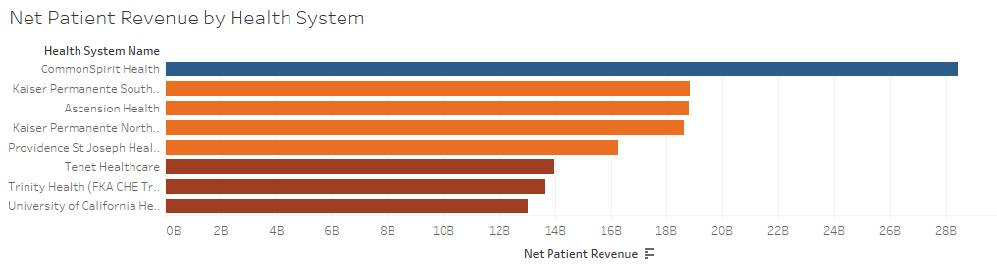
Figure 1: Net patient revenue by health system (filtered)
The first step of the analysis was looking at some descriptive statistics of the dataset in SAS (Table 1). There is quite a large range within some of the variables and it is obvious that there is a lot of money at play here. This is a big industry and market, and there are lots of opportunities to gain revenue. There is also a lot of disparity between health systems, many are extremely small and may possibly outsource the majority of their lab services so there would be little need for Accumen to contact these places for business.
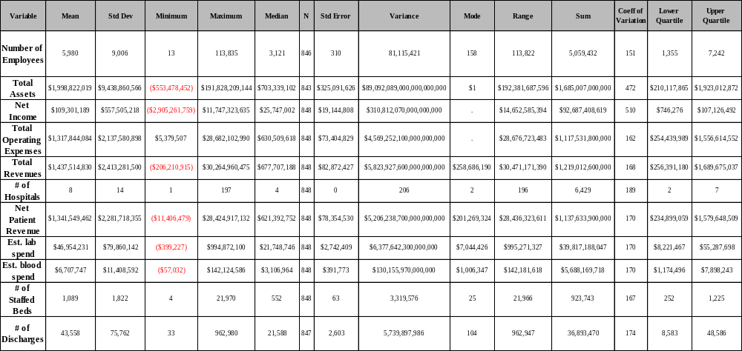Table 1: Descriptive Statistics of variables
Following that, using SAS, the Pearson’s correlation coefficient was calculated for the variables (Table 2). The variables estimated blood spend and net patient revenue were thrown out because the estimates for lab spend and blood spend were created from an assumption based off the net patient revenue of the health system (3.5% of net patient revenue was used to estimate the lap spend). Given this, total revenue being the next highest correlation was selected to be the x or predictor variable in the subsequent linear regression. As seen below in Table 2, there is a nearly perfect positive correlation between total revenue and lap spend (.99). The p value is less than alpha for each of the correlations which shows them to be significant.
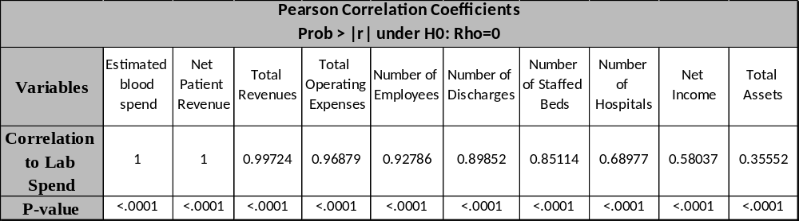
Table 2: Correlation of variables
Next, linear regression was used to try and discover a way to predict lab spend of a health system. This was performed in SAS (Figure 2), Tableau (Figure 3), and Excel (Appendix 1, Figure 4). All the results were similar if not nearly identical.
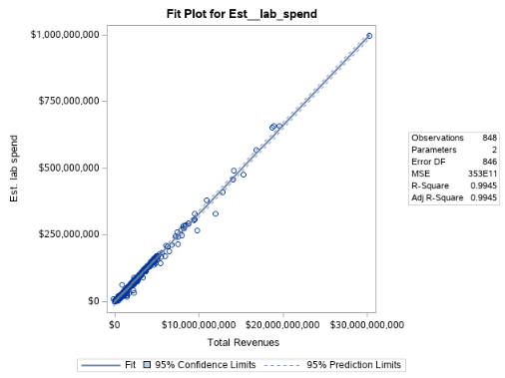
Figure 2: Linear regression in SAS university edition
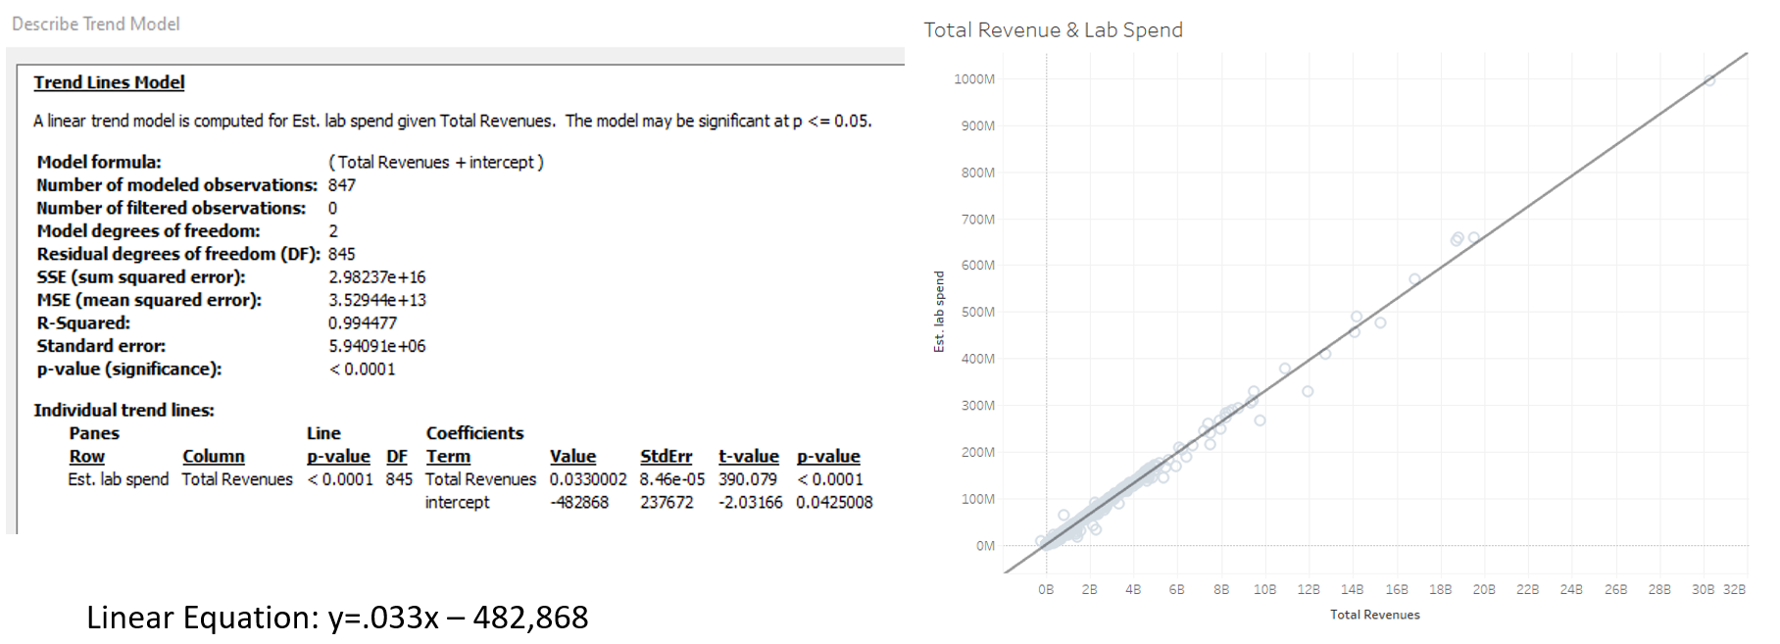
Figure 3: Linear regression in tableau
As the p value was less than alpha, the null hypothesis was rejected. This allows the linear equation to be used with more confidence to predict the laboratory spend of health systems. Using Tableau, other visuals were created to help answer business questions about the data. These are available in Appendix 1. Figure 5 (Appendix 1) shows a filtered view of estimated lab spend by health system with a bubble chart, and Figure 6 shows estimated lab spend by state. It is difficult creating visuals for the data because it is hard to show all the different health systems (approximately 850).
Programming Codes
As this paper has page restrictions, the code and screenshots of outcomes will be in an additional attachment called Appendix 2.
GitHub
The link to the project code and write up available in GitHub is here and in the references: https://github.com/hauerpc1/capstone (Github, 2020).
Project Writeup and Self Evaluation
These forms are separated documents that have been filled out and attached in Canvas.
Conclusion
This study revealed several points that will make it easier for Accumen to predict and find health systems with high levels of laboratory expenditures. Given Accumen’s business, it is important to find health systems that have high levels of lab spend as these would make for the best potential clients. The lab spend figure is not widely reported and hard to find. Accumen has been struggling to know which health systems to reach out to. By using Pearson’s correlation coefficient, it was discovered that total revenue has the highest correlation to the estimated lab spend. Then linear regression was used to create a formula to predict lab spend in the future. Since the null hypothesis was rejected, the linear equation can be used for lab spend estimates. The total revenue is easier to uncover than the laboratory expenditure total. This will help direct further analysis and begin to create a profile of Accumen’s target demo. There are other benefits to this analysis as well. Not only will this help Accumen with business development and targeting of potential clients, but it also can serve as a vetting process for onboarding clients and will provide direction for further analysis on client profiles to be done going forward.
References
Accumen. (2020) Accumen information. Retrieved from https://accumen.com/
Chandra, A., Finkelstein, A., Sacarny, A. and Syverson, C. (2016). Health care exceptionalism? Performance and allocation in the US health care sector. American Economic Review, 106(8), 2110–2144. https://doi.org/10.1257/aer.20151080
Chi Solutions. (2016). Accumen, Inc. acquires chi solutions for continued growth. Retrieved from https://accumen.com/accumen-inc-acquires-chi-solutions-for-continued-growth/
Halfpenny Technologies. (2019). Accumen acquires halfpenny technologies
CSU Global. (2019). MIS581 Interactive Lecture.
DHC. (2020). Definitive health care. Retrieved from https://www.definitivehc.com/
Fisher, J. and McKendry, K. (2019). Health care data Privacy trends: Risks and costs of third-party data collection and cyberattacks. Journal of Health Care Compliance, 21(2), 41–44. Retrieved from http://search.ebscohost.com/login.aspx?direct=true&db=her&AN=135700650&site=eds-
Github. (2019). Retrieved from https://github.com/hauerpc1/capstone
Grover, V., Chiang, R. H. L., Liang, T.-P., & Zhang, D. (2018). Creating strategic business value from big data analytics: A research framework. Journal of Management Information Systems, 35(2), 388–423. https://doi.org/10.1080/07421222.2018.1451951
Oh, J. Kang, J. & Park, J. (2019). A study of smart healthcare service model based on cloud platform: Focus on small and medium sized hospitals. Medico-Legal Update, 19(2), 434–440. https://doi.org/10.5958/0974-1283.2019.00216.0
Kemp, K., Santana, M., & Hude, Q. (2018). Interactive data visualization of patient experience and inpatient datasets using tableau desktop. International Journal of Population Data Science, (4). https://doi.org/10.23889/ijpds.v3i4.632
Rogers, E. M. (1966). Physics for the inquiring mind. Princeton, NJ: Princeton University Press.
Sanders, B. (2020). Data literacy and data analytics. RocktheViz. Retrieved from https://rockthevizcomm.com/feature/data-literacy-and-data-analytics/
Snyder, J. (2019). Data cleansing: An omission from data analytics coursework. Information Systems Education Journal, 17(6), 22–29. Retrieved from http://search.ebscohost.com/login.aspx?direct=true&db=eric&AN=EJ1224578&site=eds-live
Yoo, J. (2019). Housekeeping tips to mitigate data security risk. Journal of Accountancy, 228(3), 1–4. Retrieved from http://search.ebscohost.com/login.aspx?direct=true&db=bth&AN=138492949&site=eds-live

Appendix 1
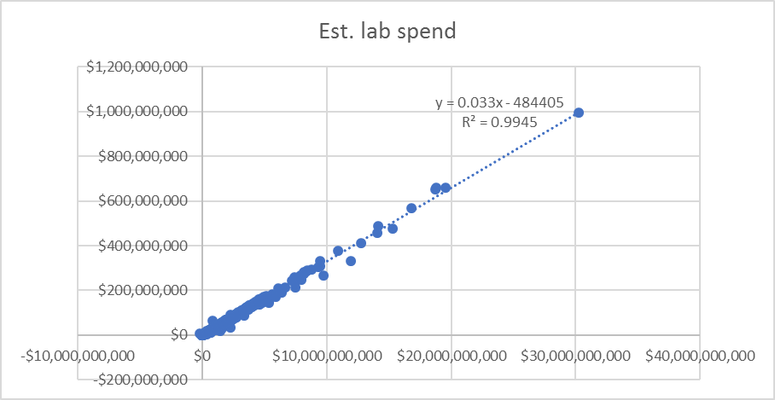
Figure 4: Linear regression in Excel

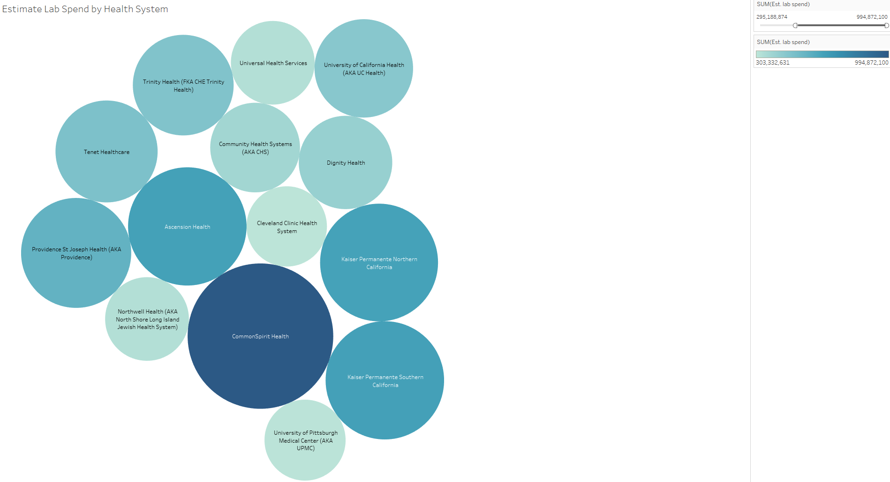
Figure 5: Lab spend by health system bubble chart

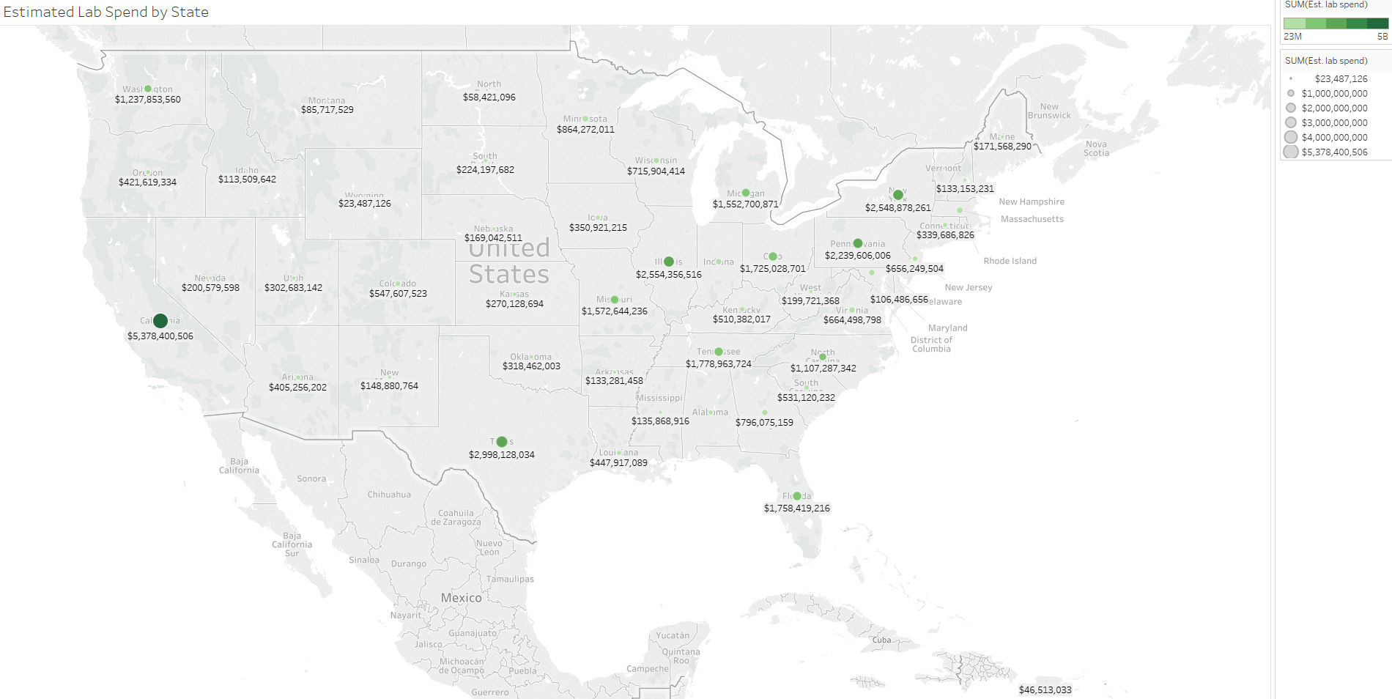
Figure 6: Lab spend by state

